WHAT DO THE STARS SAY: OUR “OFFICIAL” ZODIAC SIGNS FOR KIDS
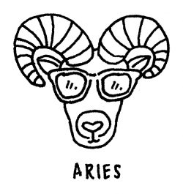

ARIES (MARCH 20-APRIL 19)
Be prepared to stay on your toes, Mom! Rams of all ages are full of energy, are pretty independent (OK, stubborn at times) and tend to be on the more adventurous side. Hope you can keep up! These are playful, fun kids who need you to course-correct
when a gentle reminder won't do. On the up side, Aries kids are natural born leaders with dynamic personalities who learn best by doing and by following your good example.
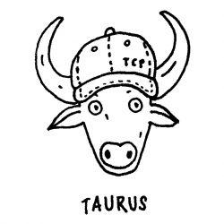

TAURUS (APRIL 20-MAY 21)
Your little Taurus is a gentle charmer who does best with structure, affection, and stability. Working with them on creating a routine or schedule they can count on will help keep things sailing smoothly on the parenting front. And Mom, keep this in your
back pocket: Taureans love little (or big) material rewards for a job well done. Just sayin'!
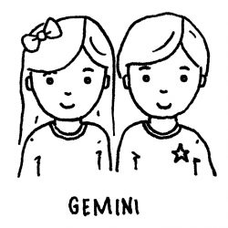

GEMINI (MAY 22-JUNE 21)
Have an inquisitive, investigative (“I need to know!") little chatterbox on your hands? Welcome to parenting Gemini kids, who are upbeat, adventurous, and freedom-loving. You may notice that one day they're up and the next day, not so much. The trick
to getting your little twin on board is to creatively channel these mood fluctuations. By that, we mean communicating openly and often. The surest way to a Gemini's heart? Through their mind!

CANCER (JUNE 22-JULY 22)
If you've got a little “dreamer" in your family, chances are they're a Cancer. These are very family-driven children who are protective (some might say even over-protective) of their clan. While affection and a good hug might fix most oops! scenarios,
little Cancerians have been known to turn on the waterworks to get what they want. They're innately sensitive, though, and can read others' emotions well, so keep that in mind before you lose your patience with your soft-hearted little crab.
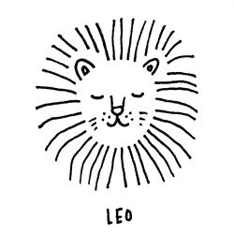

LEO (JULY 23-AUGUST 22)
The attention-loving, outgoing kid putting on a “show" for you at a dinner party? That's likely a little Leo at their best. The zodiac's little lions are fiery, fierce when they have to be, loyal, and passionate people, even when they're teeny-tiny. Yup,
they're a handful at times, but they're also loving and kind. They've got big hearts and would do just about anything for those they love. Lucky you!
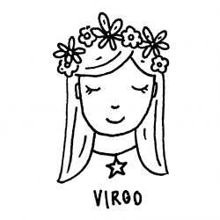

VIRGO (AUGUST 23-SEPTEMBER 22)
Want in on a valuable Virgo secret? Engage these little helpers, and you've got a constant companion. Whether you're cooking in the kitchen, cleaning the garage out, gardening, or even just taking out the garbage, Virgo kids like feeling useful and helpful.
Especially when they're trying to show you that “Hey, I'm a big kid now and I. Can. Do. This!" Be patient with your little detail-oriented perfectionist, because they like things just so...even when the clock is ticking and you're sweating getting
them to school on time. Deep breaths, Mama!
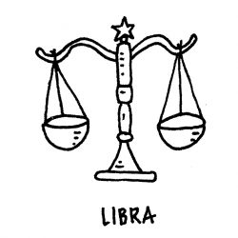

LIBRA (SEPTEMBER 23-OCTOBER 22)
These are diplomatic kids who are both compassionate and intelligent. You may find your little Libran likes to keep things neat and has an even temperament. So, they're pretty easy going as far as raising them goes - right? Sure, but here's the thing:
they also really don't like making decisions when they feel pressed, and can get down if they feel misunderstood. Mom, keep the lines of communication open with your child and gently teach them that even not making a decision has consequences
— a tough lesson for some Librans of any age.
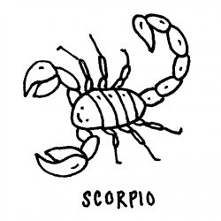

SCORPIO (OCTOBER 23-NOVEMBER 22)
"Intense" is the word that best describes most Scorpios, no matter their age. They're quick to grasp concepts, hard-working, straightforward and honest (don't ask if you don't want to know because you'll get the straight goods from young Scorpios especially!).
A word to the wise: don't try ignoring a Scorpio as a parenting tactic because what they get up to might give you a new set of grays. A firm, guiding hand will net you better, happier results, Mom!
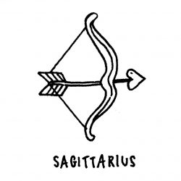

SAGITTARIUS (NOVEMBER 23-DECEMBER 21)
One of the most social, high-energy and adaptable signs of the zodiac, your little Sagittarius likes to explore and discover. Some of them do this through athletics, even if they tend to be a little clumsy or accident-prone when younger. But one constant
remains: they like the freedom to discover whatever it is they love, be it arts, science, food, or astronomy, and they need your support and vigilance to do so safely.
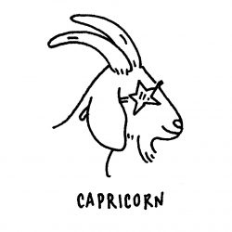

CAPRICORN (DECEMBER 22-JANUARY 20)
Hard-working, steady, responsible beyond their years — you can count on a young Capricorn to hold down the fort, metaphorically speaking. Little Capricorns like to succeed and will work hard to “get it right." When they don't, however, batten down the
fort, for a tempestuous tantrum may blow through, rocking the otherwise peaceful goat. Be there to lend a hand and steady the sails, Mom. It's what your Capricorn needs most.
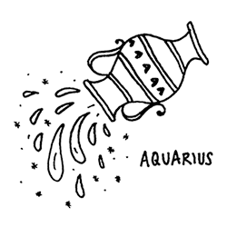

AQUARIUS (JANUARY 21-FEBRUARY 19)
Curious and clever best describe the Aquarius child. They're good-natured kids who like to learn by discovery and enjoy a good belly laugh. You'll notice they keep an open mind about a lot of things, but they also tend to be a bit shy or introverted,
especially as children. Encourage them to share their thoughts and feelings, but don't push too far, too fast - or you'll end up with a kid who is even more introspective, when what you want to do is encourage more of that kind, freedom-loving spirit.
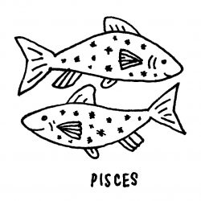

PISCES (FEBRUARY 20-MARCH 19)
Your little Pisces may be sensitive and keenly attuned to the feelings of others, but they're definitely no pushovers. Other kids might mistake their gentle, non-aggressive personalities as a weakness, but they'd be wrong. Piscean children will stand
up for what they believe in, even if that goes against their peace-loving nature. These are the helpers and natural teachers of the zodiac, especially when it comes to other children. You'll just want to make sure they're not spreading themselves
too thin, or being pushed around, Mama.

